Extracting ZIP File
- Locate the zip file in Windows Explorer
- Right-Click the file and choose Extract All

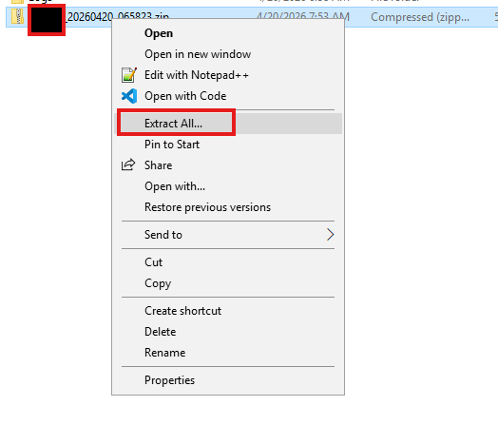
- Click Extract

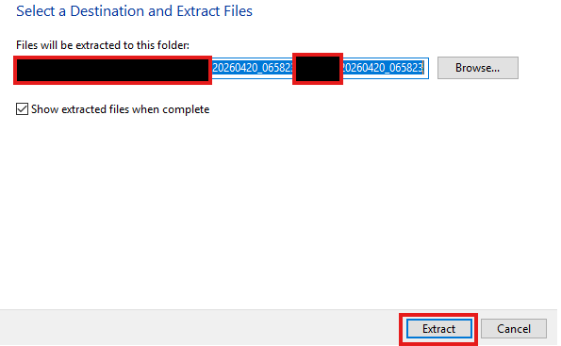
- Enter the password provided and Click OK

